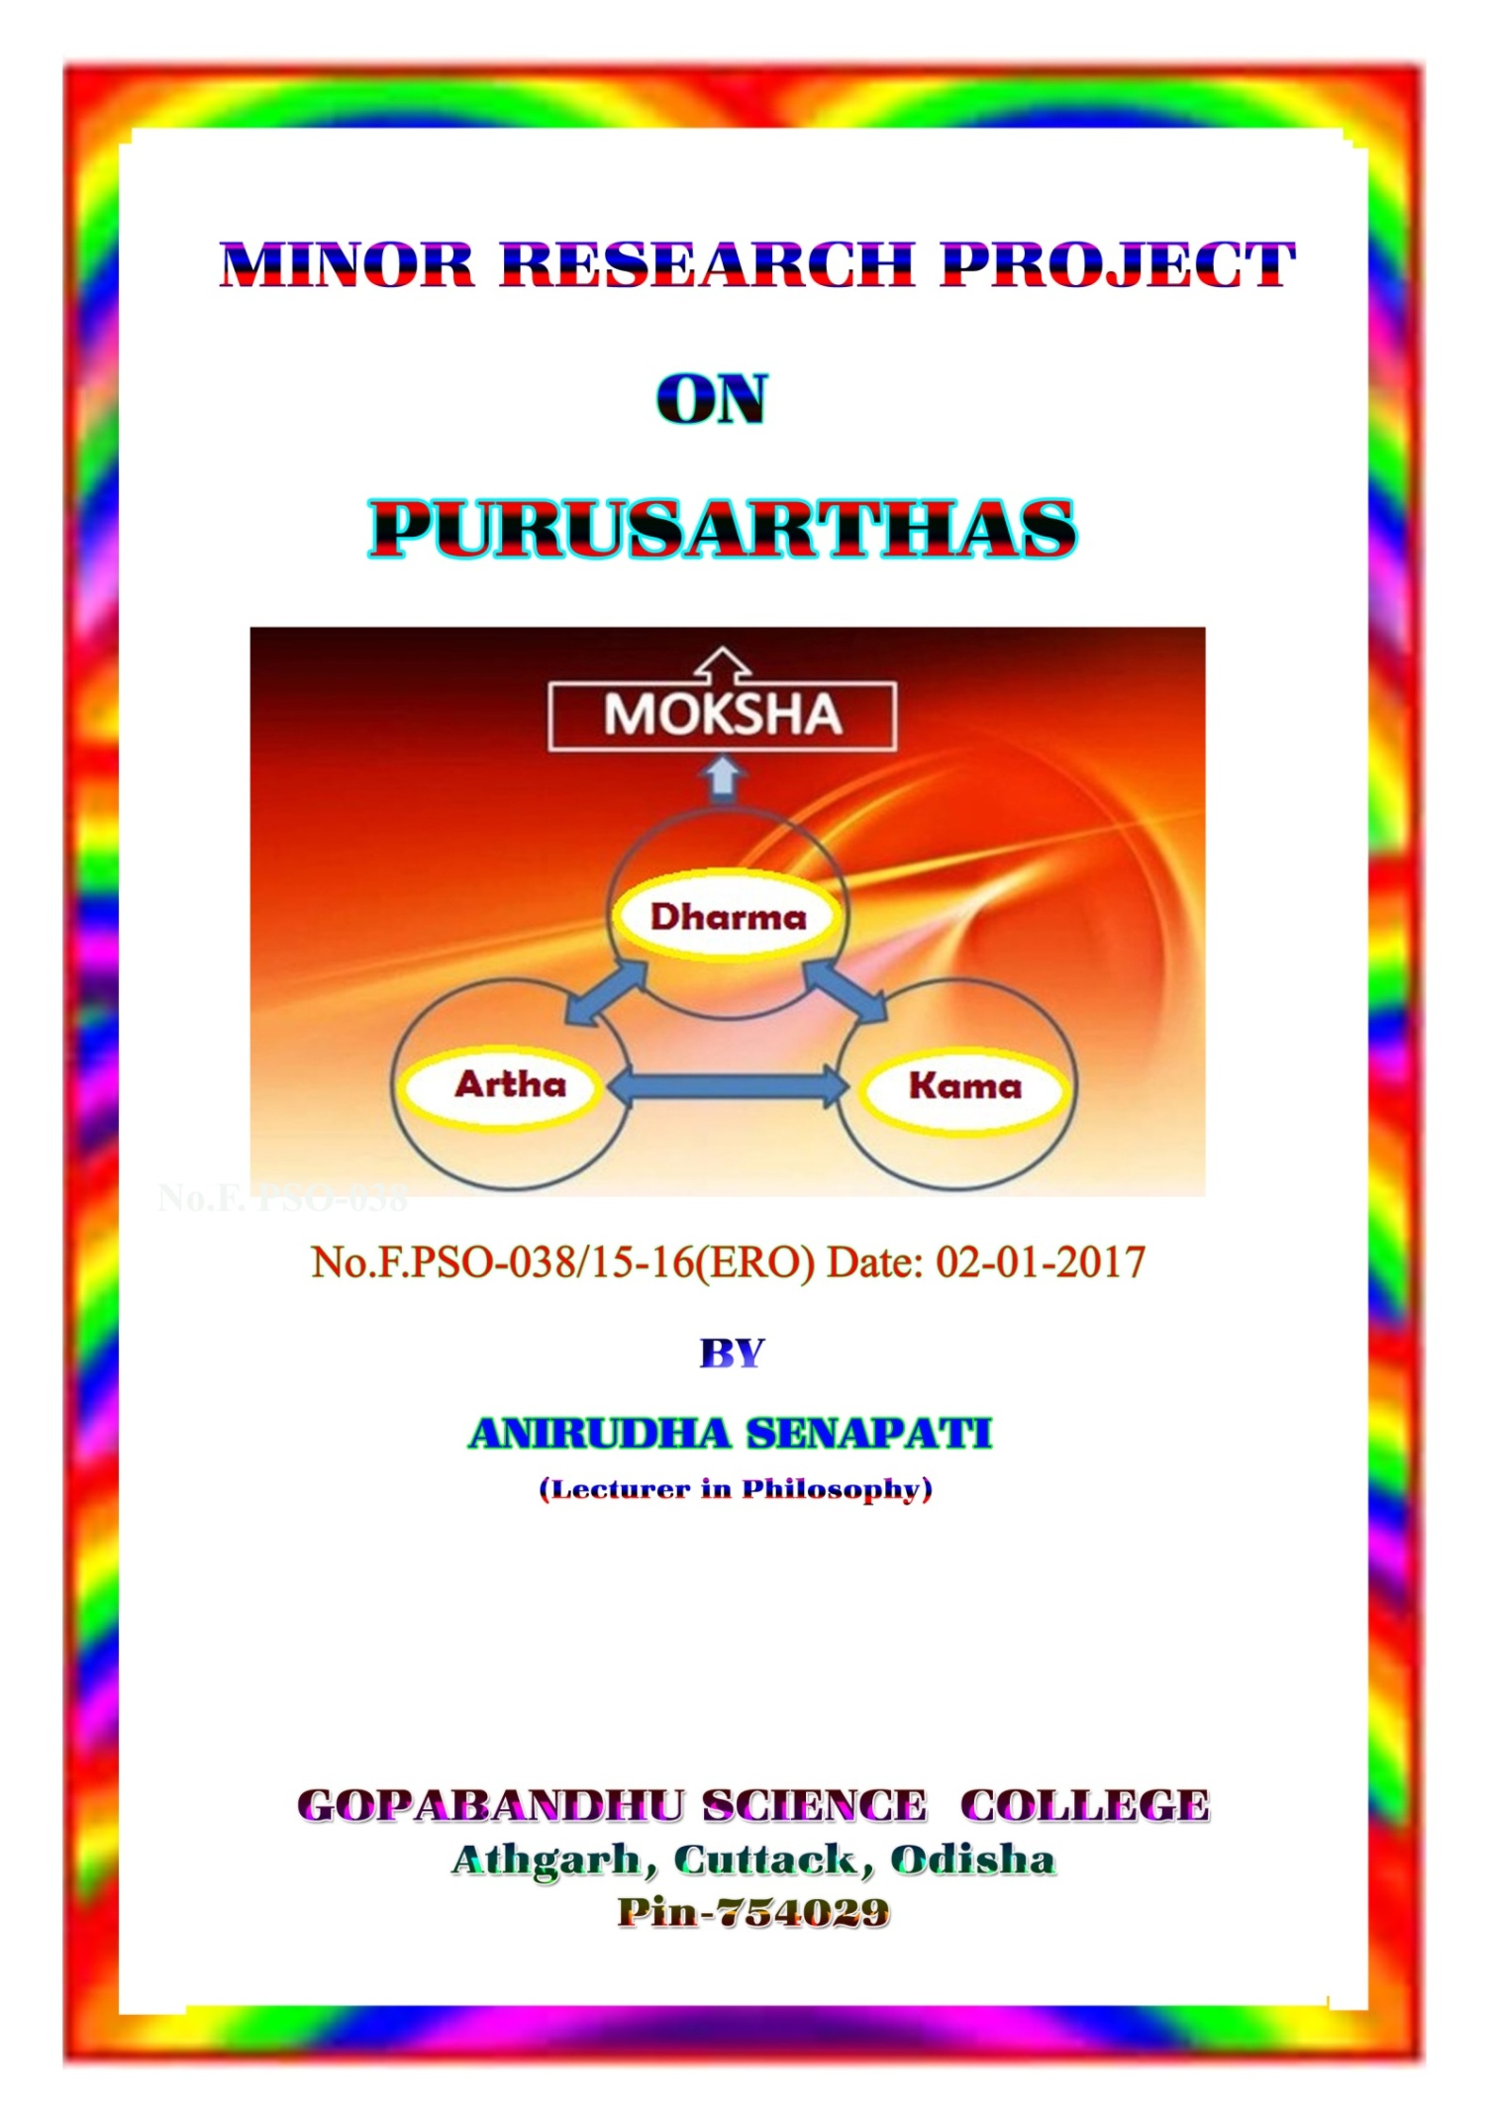

CONTTENTS

Sl.No CHAPTER PAGE
ACKNOWLEDGEMENT
- INTRODUCTION 1-6
- KAMA 7-13
- ARTHA 14-19
- DHARMA 20-31
- MOKSA 32-43
- CONCLUSION 44-49
- BIBLIOGRAPHY 50-53

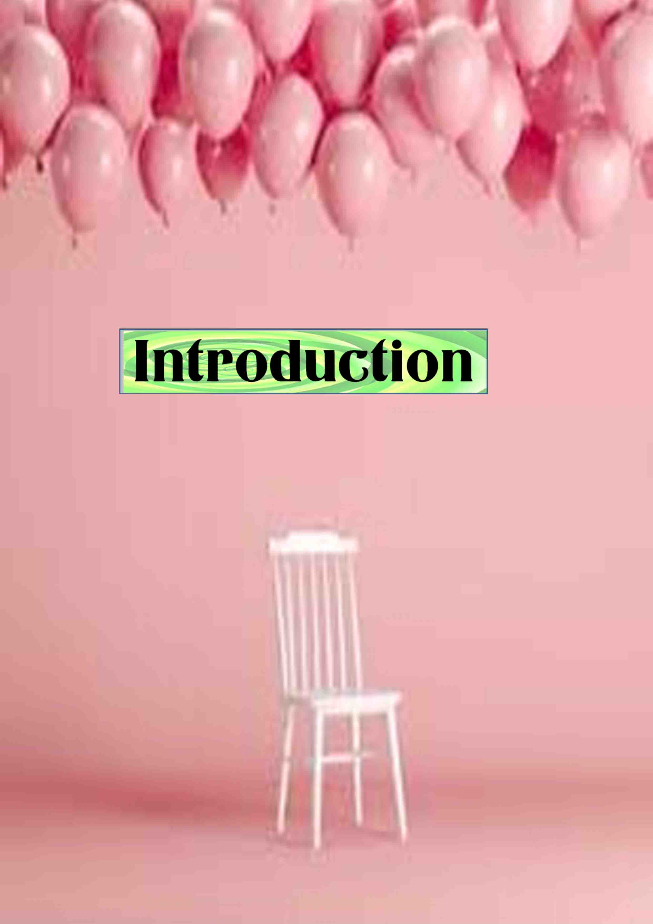
ACKNOWLEDGEMENT
At the outset I express y dee sense of gratitude to my supervisor and guide Dr. A.K Mohanty (Retired Professor) Post Graduate Department of Philosophy, Utkal University, Vanivihar, Bhubaneswar for his able and scholastic guidance, ceaseless encouragement, timely advice and suggestion, non-stop supervision throughout the period of my project work.
I am highly grateful to Dr. Lokanah Sahoo, Principal G.Sc College, Athgarh for providing me all sorts of help. At this moment I must thank all members of the teaching and non-teaching staff of the college, Athgarh for their co-operation and encouragement.
Last but not the least I express my sincere thanks to Rajesh Kumar Moharana & Malaya Kumar Behera for the help and co-operation in computer typing and designing with scanning of photographs and figures.

INTRODUCTION
The doctrine of purusartha in Indian philosophy lays down a scheme of human existence and the goal of human lie. It denotes central classical theories of human values or philosophy of life. The word ‘purusrtha’ is a compound Sanskrit word ‘purusa’ and ‘artha’ which means prusasya artha, ideal of individual. In other words purusasya artha means which meant for human beings. An individual is the creature of society and he is influenced by the social customs and tradition. Man is a social being. Society is a unity of such individuals who are independent of each other. The individuals are united in a society through ideals, custom, tradition and value of life.
The individual needs to live a harmonious, prosperous and peaceful life in a community. It is ‘values’ that equip man with the sense of goal or purpose. They regulate our desires and actions. Man is propelled by instinctive drives and desires. ‘values’ not only determine the course of man’s journey but serve as the basis of integration in the collective life. Charvaka’s denial. “All human values which make life worth living”. Life without values is the animal life, not the human life”. Man occupies the centre stage of the creation process. Individual remains responsible for all his omissions and commissions, good or bad.
The individuals, constituting the corporate body, are different from each other in respect of caste, colour, creed, race and nationality but the values they imbibe make them oblivious of the superficial differences. ‘Values’ is the prime necessity in corporate living. The classical Indian society provides the formulation of the theory of purusartha. Human aims at or ought to aim at certain goals called the purusarthas. The classical Indian society divided the human existence in to four stages known as asrams and that of the society into four castes known as Varnas. Purusarthas are not only goals which are sought but also goals ought to be sought in order to make a human’s life well lived. The purusarthas are meant to give us a normative orientation to life. The quality of living on the part of an individual and the collective body depends on the nature of ‘values’. Man has not the capacity to distinguish between value and disvalue and he has the capacity to choose the way of the former.
The aim of life of an individual is determined by the doctrine of purusartha. It also decides the course of life of man and lays down norms and values for the behaviour pattern. The individual is to achieve the aims, goals and ultimate value of life. The term ‘purusarha’ not only denotes what the objectives of life should be but it also means that the objectives of life are the result of the psychological tendency of the individual. The basic presupposition of the scheme of values as envisaged by its proponents is that man is neither a physical organism nor a mere spiritual self but a totality consisting of the physical, psychic and spiritual. Value system provides norms of our behaviour. Value plays an important role in life. Purusartha is based on a complete view of man and society. It stipulates the ideals in respect of the physical, psychic and the spiritual pursuit of man. The concept is an integrated approach to the value system. It deals with the ideal of life or goals of life.
The purusartha provide an account of the primary goods which a rational person requires. These good which include income, material possessions, bodily pleasure, psychological enjoyment. The human species as a whole have a common ancestry. Human existence is essentially value-centric. Purusartha signifies human aspirations for an ideal life or a pursuit of human objective referring to both the material aspect and the spiritual aspect of human life. Human beings on account of possessing, ‘reason’ and ‘freewill’, have the capacity to distinguish between righteousness (dharma) and unrighteousness (adharma) the pleasurable (preya) and the preferable (sreya) and move expeditiously on the path of excellence (pustimarga) leading to the attainment of the state of highest good, summum bonum of life.
In Indian tradition human life has multiple dimensions represented through furfold purusarthas, viz artha, kama, dharma and moksa called caturvarge. The first three viz, artha, kama, dharma are called trivarga concerned with worldly aspects of human life. The last purusartha i.e moksa is said to be concerned with the spiritual aspect of human life. All these values taken together can be said to have taken care of both the worldly and spiritual aspects of human personality. Purusartha is not a technical term but a word of common usage in Sanskrit and many modern Indian languages. Hiriyanna stated, “It is to mean a human value consciously pursued an object of desire”.
Artha, kama, dharma and moksa have been underlined as four fundamental pursuits of life constituting the value schemata. ‘artha’ recongnises the need for material things in order to live a suitable life, material possessions in various forms. ‘Kama’ is understood as the satisfaction of desires called ‘pleasure’, ‘Dharma’ is understood as the social and moral obligations or duties. ‘Moksa’ is understood as the freedom from all sorts of bondages and sufferings also sometimes refers to a state of bliss. All the four purusarthas mutually supplement each other. Artha and Kama are the basic and primordial values. Artha and Kama satisfy fcertain basic needs of man. Artha denotes the totality of all material things or conditions which are necessary to enable man to successfully pursue whatever he aims at. It is called the totality material means or instrumental goods. Kama denotes the agreeable feeling or pleasure, resulting out of the satisfaction of a desire. It is fulfilling one’s desire. Desires are in various forms to be wealthy, powerful, sexual needs, recognition and service. Dharma denotes the totality of moral as well as non-moral obligation, the totality of prescriptions and prohibitions, which govern the network of social relationships. It includes the obligations one has to fulfill in virtue of his office, his position in society, contractual transactions. He has entered into with some other member or members of his society. Moksa indeed, is construed as the most important and the supreme value parma-purusartha and dharma directly and the other two indirectly constitute the means to Moksha.
The four purusarthas taken together emphasize the action oriented nature of man. All the four purusarthas mutually supplement each other the concept of man is intimately connected with the concept of purusarthas. One cannot understand one without the other. The concept of man is a value concept and the purusarthas supply value to it. Purusartha literally means that which is person specific. Human existence is physic-psycho-spiritual. It is worth nothing that ‘mind’ emerges and becomes functional against the appropriate physical base. Spiritual unfoldment takes place against appropriate physic-psychic base. Human man has the capacity of self-transcendence by virtue of which it can go beyond thoughts, words, actions and make them the objects of moral valuation whereby they are viewed as desirable or undesirable, right or wrong. The doctrine of purusartha spells out the nature of the value which helps one move on the path of progress leading to the attainment of the ultimate goal.
Artha, kama, dharma and moksa are fourfold cardinal values. They are rightly termed as prusarthas. They aim at integral development of native faculties of a person. Artha signifies the acquisitive principle in man. The development of moral virtues, to great extent, depends on economic well-being. Artha denotes all types of material goods needed for our normal living. It includes the material means for the performance of our religious, social, legal and moral duties. Kama stands for the instinctive principle of our human personality. ‘Kama means desire’. Kama has an important role in man’s life should be regulated by dharma. Dharma brings order and harmony into the economic and emotional aspects of life. Dharma denotes the essence of a thing, custom, ritual, legal system, religion, morality. Dharma keeps the society on the track of progress. Dharma denotes one’s obligations by virtue of his status in society in his life history. Dharma provides the moral principle by which human life becomes meaningful and worth living. Dharma is dynamic concept which provides principles that take care of the individual and society. Without dharma individual cannot attain moksa, the ultimate end of life. Moksa stands for the spiritual principle and it also said to be a state of bliss. Moksa is the consummation of the process of our moral development and the ultimate goal of human life. Moksa is declared to be the ‘parampurushartha’ or the supreme goal of human existence. And dharma or moral life is proposed to be the means to moksa. Because dharma directs the people to walk along the right path by regulating artha and kama. Purusarthas supply the values or the ideals to be pursued both at the individual and social level. The doctrine of purusarthas takes into account all the aspects of both individual and social life.

KAMA
Kama is one of the cardinal values in Indian philosophy. Kama, in generic sense stands for the foundational source of desires. Kama manifests in physical desires (kamanas) or psychic desires (vasanas). Th desires could be physical, physic-psychic and psycho-physical. The desires for good food, agreeable fragrance, to enjoy beautiful sight, a sonorous sound or a soothing touch on the body are physical in nature. The desire for comfort and luxury of life, better living ambience are physico-psychic have origin in the body and expression in the psyche. The psycho-physical desires have origin of human psyche, its expression of seeking fulfillment in the physical domain. The desires is to be in the state of happiness, inner composure, completeness, harmony are psychic in nature. Human desires are insatiable. Human wants are unlimited. The more one gets, the more one seeks. The desire of tongue to feast on delicious dishes, cannot to tasted in the whole life. The craving of the eye to ragale on beautiful sights cannot be completely fulfilled in the short span of life.
The process of enjoying the objects of sense, the sense organs get exhausted, losing capacity to enjoy anymore. This points to the paradox of the pleasure seeking nature of an. Kama means desire, the theory of purusartha denotes the satisfaction of desires, enjoyment resulting out of the fulfillment of desires. Kama is said to be a categorical representation or hypostatization of man’s appetitive of life pursuit. Kama means pleasure or agreeable feeling, resulting out of the satisfaction of a desire. Desires are in various forms to be wealthy, powerful, gratification of sexual needs, recognition and service. Kama defines the goal of life. Kama as passion, signifying sensous desire, desire for material attainment, is patently illicit. A desire is psychic. The urge of a creative scientist to get lost in experimentation, intense yearning of a poet to get absorbed in the bounty and panorama of nature, are obviously directed at things, subtle, sublime and non material. Innate craving of the individual to grow into an archetype, to attain perfection, to attain bliss, infinite happiness its object of the ultimate reality or the transcendental of the nature of sat, cit ananda. Human existence is trifarious physical, psychic and spiritual. Kama is one of the purusarthas, cannot the sorts of desires reinforce and nourish the desire for the blissful state being attained, all desires find their absolute fruition is precisely the state of moksa.
Kama is ordinarily termed as pleasure. A finite cannot satiate the desire for infinite pleasure. Complete annihilation of desires is not possible. One lives with the body. ‘Desires’ continue to be there demanding attention and effort of the individual to get them fulfilled. Desires generate a sense of lack or deprivation. It triggers effort on the part of the individual to satiate the want and replenish the sense of void. Suppression of desires is not desirable as it results in aberration. Our desire spring from the physical and psychic needs. Desire for food, clothing, shelter and health centre around physicality or the individual the urge to know more and more is the innate psychic desire of the individual. Obsession for the physical desires make one forget the pschic well as spiritual desires. The physical ad psychic desires completely fulfill a kind of void. One cannot put an end to the physical desires. The more one gets, the more one craves for. One cannot have complete satiation of desires in the physical plane. The desire of the mind is insatiable. Only the spiritual hunger stated. The desires in the physical and psychic sphere have to be attended to the extent, they help one achieve spiritual fulfillment. Desires cannot be considered as the end by indulging in one desire, it did not come to an end it gives rise to other desires. Dharma is considered as instrumental value, it is a means for acquiring objects in the world or for fulfilling desire. Dharma constitutes the ground for excellence in the pursuit or artha and kama. Kama is the satisfaction of sexual, emotional and artistic life. Kama is the pursuit of pleasure. Kama in the narrow sense means sexual pleasure, in its broad sense signifies all the pleasures of the pleasures of the senses. Kama is a necessary element in human life and pleasure must subordinate to dharma and artha. Kama is an irresistible force. A person highly indulgent fails to understand what is good, what is proper.
Kamasutra of Vatsayana dwells at length on the philosophy, psychology and the art of fulfilling the libidinal desires. Marriage is a holy sacrament makes perpetuation of human species possible. Unregulated passions (kama) don’t take us anywhere and in this respect man remains no different from other living animals. Devoid of the sense of purpose, life becomes random groping and human pursuits remain no different from animal pursuits. He is not better than a beast. Man treads the path of animals, he becomes no better an intelligent savage. The necessity of dharma as a regulative principle, transform the passion (asakti) into devotion (bhakti). Every occasion in life is to be seized as an opportunity t move on the path of (sreya) excellence leading to the attainment of the state of infinite happiness or bliss (ananda). Man is endowed with the sense of goal that helps one to find the way of pleasurable (preya) and the preferable (sreya).
Kama, in its generic sense, stand for urges, desires, passions, yearnings and in its narrowest cannotation, signifies the libidinal urge i.e sex…. Instinctive urges like hunger, sleep, sex are characteristically physical…The desire for delicious food and luxurious house have their root in physicality, psycho spiritual desires have their genesis in human psyche but find culmination in spiritual realization. The desire to compose music is caused by the aesthetic faculty, in course of time it may take one to a state of ecstasy one experiences the divine melody, in every sight and sound of nature in its fury
The difference between the desired and the desirable is too fundamental to be ignored. Desires are end specific. Animals and birds, i.e subhuman species, have no desire but appetites. An appetite is of the nature instinctive urge. Sex is found in human being, take the form of desire (kamana) a desire is backed by consciousness and will. On account of being more evolved human beings are conscious of the object of desire (end) and the means of its satiation. Awareness of means and ends. Together with the sense of right and wrong enables are to distinguish between what one really desires and what one ought to desire.
Desires originating the physicality reveal that they are insatiable. Sense organ tends to run after the objects wit he tendency to derive an agreeable feeling (pleasure). As long as the object is not achieved, there is longing accompanied by a sense of dissatisfaction. But in the event of its fulfillment, the longing not cease to be thee as there are still more objects in view. Example, the sense organ and the eyes. It is not humanly possible to cater to the demands of the visual sense organ seeing all the beautiful places, scenery, paintings. Within the finite span of human life. The sense organs are allowed absolute latitude, these senses at a point of time, get exhausted. The body has been likened to charity the sense organs as the steeds, mind as the rein and the intellect as the charioteer and the self as the lord of the chariot. If the horse like senses are not properly restrained, they may run amok, subjecting the charioteer and chariot to uncertainty and destruction. How ofter do we experience the tension within us when incompatible desires pull us in conflicting directions? This calls for exercising restraint on the sense by the rein like mind. Individuals undergo tension when there is conflict between the lower and the higher desires, the vegetative and the rational self. Appetitive self makes one earth bound, and one acts when the sole goal of selfish appropriation. The conscience (enlightened rationality) makes us disapprove them. As a result, there is conflict between the self regarding and other regarding motivations. Good and evil coexist till the state of perfection is achieved. The fact remains that man being essentially divine, good is native and evil is an acquired trait. There is necessity of disciplined gratification of the sense-born desires. Kama, as value pursuit, advocates neither suppression nor annihilation of senses which is neither possible nor desirable, but sublimation of them. Annihilation is unnatural and suppression results in psychic aberrations. Kama in the sense of erotic pleasure (sex) has received adequate attention of thinkers in the past. Vatsayana’s Kamasutra dwells at length on the philosophy, psychology and mechanics of sex. While recognizing sex as a dominant motivation, their analysis offers ways of sublimating this elemental urge. Marriage is extolled as a holy sacrament which offers opportunities for men and women to enter into the creative companionship. Garhasthya as an asrama provides conducive environment where the primitive urge is transfigured into sublime love where there is real union of mind and heart.
Irrespective of what one desires, mind plays a pivotal role in helping one to satiate the desires. There are desires which are out and out psychic. Movement of the mind is either introversal or extroversal. It has for its objects ‘thoughts and experiences’ within or ‘objects and experiences’ in the outer world. When mind functions under the influences of lower propensities, it runs after the pleasurable (preya). When it has for its object subtler something subtler than itself, it moves towards the preferable (sreya). The immediate and the pleasurable leads one nowhere, bind the mind to the vortex of suffering. Rationality is a mere capacity. In order to bring good to the self it must have a direction. Hence, there is the necessity of principles which harness the mind only in the ideation and pursuit of the good. Mind has the natural tendency to move in the direction of the agreeable. The pleasure seeking mind is never contented the finite pleasures, punctuated with pain. It displays the tendency to get hold infinite pleasure i.e bliss (ananda). The insatiable craving of the senses, the unending quest of the mind are symptomatic of the longing of the self to attain infinity and be restored in its native state. So it is necessary that the physical and psychic are guide by the dictate of the spiritual. Dharma is the principle by which physic-psychic longings are harmonized towards the goal where all desires are fulfilled (aptakama) and there is nothing to be desired (akama).

artha
Artha, is normally translated as walth or means which one requires for fulfillment of material needs. Artha in a generic term means possessions that satisfy human desires. Artha is the basic necessity of life. Artha helps one to remove a state of wnt or lack, be it physical or psychic. Desires spring from the nature of body and mind. They are classified depending on their origin and the way they manifest. Desires could be physical, physic-psyshic or psychic or psycho-physical. Every desire is an indicator of something whicc one seks to have. One doesn’t desire for something which one already has. Desire points to an ‘end’, it stands in need of ‘means’, pursuit of results in its fulfillment or satiation. There is the necessity of ‘means’ (artha) for achieving the ‘end’. Artha satiates a want or a desire, irrespective of its nature physical, psychic or spiritual.
Artha means wealth or money, necessities and comforts in the physical domain. Artha is indispenseable for the maintaining of physical existence. It not only helps one to fulfill the basic needs by way of having access to food, clothing, shelter, education, medicine and comforts of life but also the other wants which one creates for oneself. Kautilya stated that “Wealth and wealth for their realization“. Artha helps one to ward-off poverty and ensure economic security. In the social plane, artha brings economic security which is one of the prerequisites of social solidarity, political stability, growth and embellishment of the social psyche. Artha signifies ‘meaning’ which removes psychic wants.
One doesn’t know the meaning of a particular term or expression, it creates a want. It means one understands the meaning, the want ceases to be there anymore. Unbrided pursuit of artha turns out to be determental to the individual and collective body.
Artha is necessary but unregulated pursuit of it takes one to a state that it’s assets turn to liabilities. The pursuit of artha stands in need of regulation by the principles of dharma. In the physical domain, artha is to be pursued to the extent. It helps and doesn’t hinder the physica-psycho-spiritual development of the individual and collective body. Artha is that satiates a physical or pychic want only for a period of time. Human want are attained to, one feels fulfilled but again there are new wants. For example, food and water satiate one’s hunger and thirst. One feels want at rgular intervals, necessitating our effort to make to the ways of setting them at rest. The desire to know psychic want more and more cannot be set at rest permanently. The more one knows the more one seeks to know. The desire for recognition never gets completely fulfilled. Artha signifies the acquisitive principle in man. Artha is the satisfaction of the human needs and wants. The develop0ment of moral virtues, to a great extent, depends on economic well-being. Artha denotes all types of material goods needed for our normal living. It includes the material means for the performance of our religious, social, legal and moral duties.
Artha denotes all kind of material possessions, irrespective of their potentiality for rightful or wrongful uses. Artha stands for meaning of life. Artha as a value perspective wants to emphasize the view that every person has a right to earn his livelihood, to accumulate wealth and property. Artha is an important means for dharma like kama, artha has an instrumental value. It is a means of securing a good human life and its development. But the misuse of artha leads to social ills. Wealth is not everything, yet without wealth other values might be in peril. Today everyone is running after money. People need money to meet their basic necessities, for higher education, for luxuries of life, for name, fame. Artha is wealth one requires for the fulfillment of material needs,. Artha is to be pursued in so far as it helps one attaining the paramartha the moska. The pursuit of artha becomes a varitable disvalue, if it hinders the attainment of the highest goal.
Mahabharata points out the importance of artha “without profit or wealth, neither virtue nor the object of desire can be won”. Dharma and kama are two limbs of artha. Artha helps one tofulfil the4 basic necessities and comforts of life. The individual can undertake the psychic and spiritual pursuits without any hindrance. One cannot think of anything noble nor can one meditate in empty stomach. Besides the personal needs, the individual stands in need of wealth or artha for attending to obligations of the family and discharging of the social obligations. Artha is not be made for satisfaction of sensual desires for realizing a nobler purpose. Srimad Bhagvad states that if anyone desires more, he is a theif deserving punishments. Artha is a prime necessity. It is not to be pursued at the cost of attaining the end. Artha is understood as means or as meaning. The core meaning of artha is to remove a want or feeling of deprivation. Money is artha as it satiates a physical want. Its meaning is artha as it removes a psychic want. Artha as a fundamental value in the scheme of purusartha stands fo9r wealth or the economic pursuits, necessary for existence, growth and expansion.
Artha is one of the old Sanskrit lexicons, is said to mean meaning, money, a thing and possessions. Artha means the attainment of riches and worldly prosperity, advantage, profit and wealth. Artha is powerful urge in human nature. Artha helps the attainment of kama. The term ‘artha’ means the attainment of riches ad worldly prosperity, advantage, profit and wealth. It can indicate the whole range of tangible objects that can be possessed, enjoyed or lost and require in daily life for the upkeep of a household, rising of a family and discharge of religious duties. Kautilya asserts the term artha means “Human activity, motivation, desire and the whole earth or society where human being lives”. “Manusyanam Vrttirarthah, Manusyavati Bumirityarthah”. The term ‘artha’ doesn’t mean the wealth only.
Wealth plays a prominent role in the fulfillment of one’s desire. All kind of meritorious works and religious acts may be performed. If there is a sufficient wealth. The term ‘artha’ suggests one should fulfill one’s economic requirements in life economically or balanced way. The acquire of wealth is not merely for enjoyment, to save for future. Manu has classified man into various types. Artha is the fundamental factor in all human pursuits. Dharma and kama are subordinated to it. Artha or wealth becomes evil or a agency to perpetuate evil if it is put to wrong uses. Wealth is not an end in itself. It is a means to achieve something, it si instrumental value, the attainment an enjoyment of desirable objects one of the ends of human life. The enjoyment of pleasurable objects in the complex social structure depends on acquisition of property and wealth, of power ad position in social life. The wealth is the first end of human life. Both the possession and enjoyment of wealth are made possible for the individual in a stable social order. It imposes certain laws of good conduct and social behavior on its members. An individual is desirous of happiness receives satisfaction in his mind and refrains having more money is not essential account of the fact that satisfaction is the root of all happiness. In this context of Manusamhita is describing the duties of a king that hunting, dice, playing are described as vices or vyasanas of the king. The maincontention of description is that a king if engages himself too much in hunting, dice playing, it would come under vyasana. Too much charity or penance is not advisable as it may lead to loss of money or health. A uncontrolled and unregulated life of love and pleasure (kama) is evil and is not desirable. Rbindranath stated “nothing can be made beautiful or meaningful if there is no limit and limit has a prominent role in beautification”. Ugliness or meaninglessness in life lies there is no limitation or restriction.
Artha, is the fundamental factor in factor in all human pursuits. Dharma and kama are subordinated to it. Morality or dharma and pleasure or kama cannot remain in a society if there is no economic stability or power. Kautilya stated that the term ‘artha’ denotes both the source of income and human society supported it. An individual acquires money or wealth for the service of mankind. The economic system need some social or moral control for achieving maximum human good or for achieving society free from exploitation. Artha is opposite to anartha that cause individual harm. As pleasure or happiness (kama) is worthy of being aimed and as it has connection with our good in the satisfaction. It is described as artha. Someone finds pleasure in performing undesirable works, it comes under anartha, not artha. Money is he visible sign of a universal force. This force in its manifestation on earth works on the vital and physical plain is indispensable to the fullness of the outer life.
Artha, is normally translated as wealth or meas
One requires for the fulfillment of material needs.
The term ‘anartha’ should not have happened or
One does not want to have happened. Artha as
One of the values in the scheme of the purusartha,
Is to be pusued to the extent it helps one attaining
The paramartha the moska…Artha and kama are pursued
In conformity with dharma, one attains moksa, the summum
Bonum, Artha is the basic elements of human
Aspiration, Artha and kama stand respectively for the
acquisition of wealth and the enjoyment of the present life.

Artha or wealth is prerequisite for meeting the basic necessities of life. artha in the exclusive4 sense is the economic wealth. Artha is used in the sense of meaning of a word. In Vaisesika padartha stands for all are ‘knowable’ and ‘nameable’. It is the objects which give meaning to the words (padasya artha iti padartha). Artha plays an important role in promoting human welfare. It fulfills human wants.

DHARMA
Dharma occupies a central position in Indian thought and ethics. Dharma used in manifold senses makes people talk at cross purpose and stand on the way of arriving a tentative consensus. Dharma predominantly has an ethical overtone. It has a semantic root in Indian metaphysics. Dharma doesn’t have equivalence in English language. Dharma is translated as religion. Religion doesn’t cannote the core meaning of the term ‘Dharma’ nor does it encompass its semantic richness. Dharma is derived from the Sanskrit word “dhr” and it is said to etymologically mean “to uphold’’ and sustain the human world. The idea of dharma is of great importance here, as indeed it is in understanding the Hindu view of life as a whole. Dharma is ethics, morality, virtue, spirituality, truth and good conduct. Dharma functions like an omnibus term denoting the essence of a thing, custom, ritual, legal system, religion and morality. It relatively in narrower sense denotes the set of obligations. One is committed to fulfill by virtue of his passing a particular period in his life history, his natural and professional competence and his status in society.
The behaviour of the non human creatures are governed by instincts and external conditioning… the reflective capacity of man enables him to rise above the push and pull of the drives and endows him the capacity to distinguish between what one is prompted to desire and what is desirable… dharma provides the moral principle by which human life becomes meaningful and worth-living, moral principles are not static and pre-defined consisting of certain injunctions’ and prohibitions. Dharma is a dynamic and growing concept is to be understood with care, it provides principle to take care of the individuals and society.
In Mahabharat, dharma is stated as that upholds the society. Dharma is duty. It is the higher good to achieve the highest moksha. Artha and kama without dharma would be meaningless.
Dharma is the important urge to regulate both artha and kama. Dharma is the supreme aim. All humans have the innate urge to seek pleasure. Human desire, be it physical or psychic, springs from the nature of human existence. Desire constitutes the ends and artha is the means of fulfilling them. The more we have, the more we desire. Human desires are insatiable. Human beings have the sense of ‘ends’ and ‘means’, ‘ought’ and ‘ought not’. Value and disvalue makes sense only with regard to ‘ends’ and ‘means’. The unregulated kama makes one subject to the vicious circle of passions (Kaman) and unlicensed pursuit of artha ponders to the acquisitive instinct of man resulting in greed. Kama and artha devoid of dharma, are meaningless. Life wedded to dharma, pays in the long run. The pursuit of disvalues (adharma) appears to be expeditious in the short run, proves to be detrimental in the end. Dharma helps o determine not only the right ‘end’, but the right ‘means’. Dharma sustains the individual in the society and it upholds the society as a whole. Dharma is venerable, eternal and universal.
Dharma is the supreme goal of human life and is an end in itself. Truth (satya) is interchangeable with dharma. Truth as the real dharma of life. Dharma is established in truth. Dharma is the prime object of life. Dharma gives value to kama and artha. Dharma is the only intrinsic value. Dharma and artha produce prosperity and happiness in heaven and on earth. Vice (adharma) produces evil and harm. Dharma is supreme way and the supreme goal of man. True happiness comes from dharma. Dharma is equated with duty. Dharma is the divine constitution which defines our roles and responsibilities. Dharma that brings in order and harmony into the economic and emotional aspects of life. In narrower sense, dharma denotes one’s obligations by virtue of his status in society (varna), in his life history (asrama) and being simply a member of the human species (samanaya). Dharma and religion are used synonymously though there is fundamental difference between the two. Every religion has its founder or profounder. Dharma being beginning less, has existence. A social order proves to be stable and enduring when people live life wedded to dharma. Religion consists of abody of beliefs, prescriptions and prohibitions mode of prayers and system of observances. The individual is to live a life or righteousness (dharma).
Dharma, determines the ethical merit of an action. Dharma is used in many senses. Dharma denotes different sects and cults a Christianity, Islam and Hindusim. Dharma is used to sigify the characteristic essence of a thing or a being (Vasu dharma). The dharma of water is to flow downward, dharma of fire is to burn. The unanimous verdict of the veds, sastras and the puranas is that the universe rests on dharma, the divine law. Dharma guards man against sins and ushers him into a higher life. Dharma enables the soul to cross the great oceans of pain in this life as well as the next world, both of are full of woes. Without dharma man’s life is reduced to the life of a beast. Dharma is regarded as one of the principal means of edifying individuals life. The concept of dharma has been conceived by different people at different times. The cannons of dharma have been followed by every country and the people of every nationality.
A man who does not recognize any dharma becomes licentious. Dharma makes a man self controlled, courageous, forbearing, heroic, dutiful and a master of his sense. Dharma teaches us the virtues of compassion, harmlessness, forgiveness, commiseration, servie and truthfulness. Dharma is our sole companion and helpmate in this life as well as the next world. That dharma transports a man from the region of pain to the abode of bliss, from unreality to reality and illumines our gloomy hearts. Dharma helps us in building character. Dharma can eradicate wrongs and become instrumental in restraining kama and artha from pursuits that take one away from the ultimate goal i.e. moksa and regulating them in a way which proves to be goal promoting. Dharma provides the principles or norms.
The Indian expression of right activity is dharma. In Mahabharata is is mentioned as an ethical concept, defined as that is right and good. In Mimansa, dharma is a means to the attainment of realization and living of the truth “Aham brahmasmi and tat tvam asi”. It is waking up of human consciousness i.e the highest level of reality (paramarthik satta). Dharma is suprasesible and consists in the commands of the ved. Dharma and adharma deal with happiness and pain to be enjoyed or suffered in the life beyond. Dharma is construed as eternal moral order, constitutive property of things and beings, moral imperative, regulative principle and institutionalized practices. Dharma in the sense of the ultimate moral order, is of seminal significance, for it led meaning to the other uses of the term.
Human awareness is self reflective. It has persuaded man to seek to uncover the secrets of nature and man. The grand design and orderliness in nature keep us baffled. This is termed as dharma (moral order). The desire to move away from the state of incompleteness, ignorance and imperfection is innate in every human being, rich or poor, wise or ignorant, privileged or the marginalize, the conscious and persistent effort to move from untruth to truth, darkness to light and mortality to immortality is aptly termed as dharma sadhana, the phenomenon of perpetual discontentment of man testifies to the fact that the eternal quest of man is the quest of infinite happiness or bliss (ananda). A thought or action is construed as righteous (dharmic). It helps one move on the path leading to the goal.
Dharma as cardinal value owes its formulation or significance to nature of the reality as a whole. In the Upanisads, ‘dharma’ is equated with the cosmic order ‘rts’. Rta is to account for the immanent order in the cosmos, the laws of nature and laws of karma are of two different variants. The concept of Brahman as the primordial agent and substratum of the phenomenal manifold. Rta is nothing but Brahman subsisting as the immanent intelligence of the cosmos. Rts expresses the natural and moral order. In moral domain Rta again has two fold expressions, viz satya (truth) and dharma (righteousness). Satya is conceptual apprehension of Rta where as dharma is it’s actional expression. Brahman and Rtta refer respectively to the transcendent and immanent aspects of the cosmic reality, protasis of both the natural and the moral universe.
Dharma is used in many senses. Dharma comes out victorious. It means the way of cosmic order (dharma). The moral order is irrevocable. Human beings inhabit a moral universe. Actions are what human beings do with rational deliberation. Actions are characteristically different from events. Events are caused but action are wiled. As the substratum of the orderliness in nature, it is a moral and the ultimate ground of the karmic law. In the domain of human actions every action is good or bad, contains the potency to generate appropriate reactions. Dharms, in this sense, that sustains and runs the universe. It is moral and termed as dharma. Dharma as the principle or righteousness, is nothing but rta, functional in moral domain.
Dharma is used in the sense of characteristic essence or inalienable property of a thing or a being. Dharma is broadly classified as Vastudhrma, Jaiva-dharma and Manavadharma or Bhagavatdharma. Vastudharma stand for the characteristic properties of objects, dharma of water is to flow downward, dharma of fire is to bur. The dhara of an objects bears its distinctive identity, is an inseparable and integral part of it. Jaivadharma is the characteristic nature of the living beings. Birth, growth, decay, final extinction death, the tendency to life and perpetuate constitutes jaivadharma as it is essential to all living existent. Human existence is more psychic than physical. Manavadharma signifies qualities or expressins, i.e discoverable in every human being, irrespective of being young or old, enlightened or ignorant, rich or poor, always and everywhere, manavadharma is the characteristic essence in respect of human beings, stand out unique among other living beings,. Man is a living entity, he possesses al the characteristics of jaivadharma. Man possesses the sense of righteousness (dharma). The ability to walk on the righteous path leads to the ultimate goal. Devoid of dharma, human beings are no different from animals or other livings counrterparts.
Dharma is to be regarded as the expression of the highest law i.e the ultimate reality of Brahman. Dharma is equated with satyam. Dharma is divided into samanya svdharma and visesa dharma . Samanya dharma includes all duties common to everybody irrespective of caste of life stations. Visesa dharma is specific duty to particular castes and life station. Visesa dharma is known as varnasrama dharma is said to be the basic of the Hindu way of life. Dharma is the fundamental of sustaining principle of the universe articulated differently in different religions.
Dharma constitutes the vital throb of social body. Values constitute the pranadharma, elan vital of society. Pursuit of dharma is largely determined by personal and contextual contingencies. Dharma cannot be practiced independent of contexts. The concept of svadharma means one’s own dharma. It means the duty of a person or a class of person in particular varna. The duty of individual is to be determined by innate disposition and ability to do. Guna and karma constitute one’s svabhava or nature. Svadharma is grounded in svabhava. Dharma in the sense of an ought is meaningful only in relation to person, class, community the exigencies of time (kala) and place (desa). The concept of Varnadharma and Asramadharma are the Hindu ethics. Varnadharma expounds the nature of ‘individual morality’.
The social ethics of the Hindus are represented in a scheme of varnasramadharmas, viz duties relating to one’s asrama or specific stage in spiritual discipline. Varna is determined by guna and karma. Human beings fall into four distinct classes, viz. Bramhana, Ksatriya, Vaisya, and Sudra. Lord Krisna tells Arjuna that the fourfold classification has been created on the basic of guna and karma. Guna and karma are the internal and extroversal aspects of human agency. The classification on the basic of varna is pristine, sacrosanct and absolute. Brahmana is one in whom sattva is dominant, rajas is subordinate and tamas is recessive, In ksatriya, rajas is dominant, sattva is subordinate and tamas is recessive. In vaisya, rajas is dominant, tamas is subordinate and sattava is recessive and in sudra, tamas tamas is dominant, rajas is subordinate and sattva is recessive. Brahmana are the enlightened one’s which primary duty is to show beacon light and to lead the rest of the society to the path of righteousness (dharma). Ksatriyas are unique social class by possessing the qualities of prowess, fortitude, alertness, not shirking away battle, generosity and authoritativeness. By exercise of physical power they extend security to the rest of the society or to people who undertake respective duties without any let or hindrance. Vaisyas are prone to trade and commerce. They are worldly wise and show uncanny expertise in material transactions. Sudras do not possess the characteristic ability and disposition of the other three categories of individuals, are down to earth, tend to thrive and serve other by their physical labour. Sudras are not psycho spiritually developed. They possess the characteristics of humility to offer services to others, constitute an indispensable component of a healthy social order.
The fourfold classification of society is correlated with the fourfold basic needs of the society. Society is an organism in order to thrive and grow, to be served, nourished, defended and righteously guided. These fourfold social needs viz. Service, survival, security and stewardship are attended to respectively by sudra, vaisya, ksatriya and brahmana. The humble service of sudra is as significant and sacred as of a vipra. The elements of sudra, vaisya, ksatriya and vipra are present in every individuals. Varnadharma is person specific. Everyone has to discharge his svadharma to promote the singular end i.e establishment of dharma leading to collective well being and the consequent social stratification correspond to four fold needs of human society. A healthy and harmonious society needs the toilers (sudra), trader (vaisyas), warriors (ksatriyas) and the enlightened ones (brahmana) to the society on the path of righteousness.
Ashramadharma is the bounded duty of an individual during the different stages of life. Ashrama means a state in which one is comfortable poised. A person who lives a complete life has to live the four stage of life asramas viz. Brahmacharya, Grahastya, Vanaprastha and Sannyasa. Celibate, house holder, forest dweller, renunciate. Dharma is used in the sense of moral imperative. In varnadharma one’s duty is determined by ones nature. Ashramadharma determines what one ought to do or ought not to do. In Brahmacharya the human life is to cultivate the virtues of head and heart, in order to live a healthy, peaceful and contended life. Holistic development of the human person is possible only when one is physically sound, mentally developed and spiritually elevated. Brahmacarya is construed as celibacy and having complete control over the libidinal urge. Brahmacari is one who should normally enter into the stage of being a householder. Brahmacarya is the prime period and foundation of the whole life. Brahmacarin is to study and cultivate the sterling virtues of life. Grahasthya affords opportunity to discharge the sublime onus responsibilities of participating in the in the process of perpetuating the human race is begetting children. One learns the art of living when one comes to realize one’s strength and limitation facing the temptations and challenges of life. Garhasthya asrama is to support to people in other stages of life or helps one meet other obligations of life. The householder has a greater edge over others as he gets an opportunity to pay nack three basis debts rna, viz. Devarna, Pitrrna and Rsirna. Deverna (divine debt) is extending ptotective care to all the created things and beings (bhuta). Pitrna (debt to parents) is to be useful to all to enrich the stock of human knowledge i.e the saints and seers of the past and disseminate them to others.
A householder taking care of the family has been raised the discreet choice has to extend sustenance and care to people living in other stages of life like brahmacaris, vanaprasthis, sannyasis. The period of vanaprastha to repair into relative seclusion, prepares one for embracing the life of renunciate later. The successful completion of life of a house holder is followed by a stage in life. Retiring into relative seclusion. The life of vanaprastha is preparatory for the latter and finds complete fruition in the life a renunciate. The life a renunciate is one of uninterrupted contemplation on the divine. A sanaasin lives in the 3orld without belonging to it. He loves everything. He is absolutely detached.
Apart from the svadhrma, ashramadhara is person-specific and circumstance-specific. There are duties whichare obligatory (sadharana dharma). In nature despite the varing contingencies of the person and the circumstances. They are basic in so far as it promotes personal excellence as well as inter personal harmony and social stability. In manusrit fundamental values have been enumerated. Every individual has to cultivate it. They are dhrti (resoluteness), ksama (forgiveness), dama (endurance), asteya (non staling), sauca (cleanliness), indriya nigraha (self restraint), dhi (sound intellect), vidya (pursuit of knowledge), satya (pursuit of truth) and akrodha (control of anger). Moral progress depends on these values which are to be lived through.
Purva Mimansa discusses the nature and from of moral imperatives (dharma). An ethical injunction is said to be secular (laukika) or spiritual (sastrika) depending on the source of justification. Secular imperatives are justified in terms of considerations of space, time and person. The spiritual duties are classified into Kamyakarmas (optional) are conditional in nature and Nityanaimittika karmas (daily and occasional duties) are unconditional in nature. Kamyakarmas are scriptural injunctions relating to a particular end which the individual seeks to achieve. Nitykarms are duties like prayer sandhya, study (svadhyaya) are to be performed meticulously everyday. Naimittika karmas are binding o the individual on special occasios like funeral rites, eclipse. It is the tenets of dharma.
In the Vagavata gita the secret of dharma is said to be ensconced in the innermost being of a person. Metaphysically, the logus of the microcosm (atman) is Brahman. Dharma as the regulative principle of is grounded in the laws of one’s being is nothing other than the laws of the cosmos. It manifests in the spatio-temporal personal mode.
In common parlance, dharma and religion are used as synonymous terms. Hindusim, Buddhism, Jinism, Sikhism, Christianity, Islam, Confucianism, Shintoism are different religious professed and practiced by people at large. Religion stands for a body of beliefs, set of practices, prescriptions and prohibitions formulated by its propounder in certain social context. In jainism dharma and adharma have altogether different connotation. The reality is consisting of two co-eternal categories namely; jiva (livinh) and ajiva (non-living) dharma and adharma belong to the class of the non-living reality. Dharma and adharma have been conceived as the precondition of motion and rest. Motion and rest are perceived and dharma and adhrama are inferred as the very conditions make Motion and rest possible. Dharma is responsible for activity and creation of perceptible forms. Buddhist metaphysics is momentariness (ksannabhangavda). A thing or being is not the same in two succeeding moments. Everything is subject to the process of becoming. Each moment of existence comes into being on account of the preceding moment. The existence of a thing in a moment is nothing but its capacity to give rise to the succeeding moment. On disappearance of the present, the future moment comes into being. The present and future refer to two different moments of time. Ignorance of this truth makes one mistake the relative in the absolute, the transient as permanent. Buddha equates dhamma with the way the reality. One who sees the dhamma attains the state of nirvana.

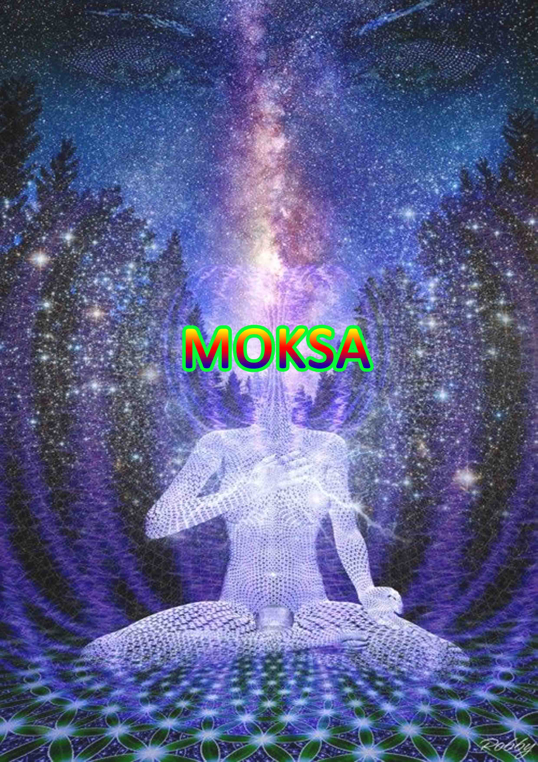
MOKSA
Moksa is the final objective of life and is to gain freedom from worldly sufferings and inevitably the continuous cycle of birth and death. This is achieved by leading a various, righteous and disciplined life. Moksa is the ultimate destination for human life. Moksa stands for the spiritual principle. Moksa is said to be state of bliss. Moksa means perfect liberation or eternal happiness. Moksa is declared to be the paramapurushartha or the supreme of goal of human existence. Moksa denotes so many things viz freedom from the chain of birth and death, freedom from suffering, freedom from karma (action), freedom from attachment to the objects of desires. Moksa is taken to be purely intrinsic value of the highest older.
Moksa is the highest end of life, attainable only by the individual himself, with the help and guidance of dharma. Moksa is the final emancipation, the ability to let go of something a purpose once completed. Moksa signifies an attempt to understand the true purpose of life. Alongwith kama, artha and dharma, moksa has been included within the scheme of human values, ends or goals. Man is just not satisfied with material wellbeing, desire for love and righteousness. He wants to realize the true purpose and meaning of his life.
The ultimate end is koksa. Dharma has only functional role in restraining kama and artha from pursuit that take one away from the ultimate goal (moksa) and regulating in a way they prove to be goal promoting. Artha and kama provide the content of action. Dharma provides the principles or norms. When artha and kama are pursued in conformity with dharma, one attains moksa, the summum bonum of the Moksa provides the ultimate justification or rationale for the pursuit of the three vargas dharma, artha and kama. Moksa is the ultimate value. Moksa is not a concept but an experiential state. It is not the prerogative of a person or a class. It is an existential state, attainable by anyone who treads the path of ‘dharma’ (righteousness). Moksa is a trans-moral state.
In Vhagavat Gita, moksa is mentioned as the supreme tranquility and the highest bliss. It is the delight in the self, contentment with the self, self satisfaction and self fulfillment. It is the highest end of life, attainable only the individual himself, with the help and guidance of dharma. Moksa as the last end signifies its attainment impossible without fulfilling the obligations of the other three. Being the ultimate value of man’s social existence, moksa is an end in itself. It is the stage where man’s cravings cease and need for attainment and fulfillment. In moksa one secures immorality, free from the cycle of birth and death. Moksa as the atonement with the supreme godhood is the highest state of religious realization. Moksa means the attainment of a state free from all pain. Moksa is the last and the final purusartha of the human.
Moksa or liberation is the ultimate destination of human life. Moksa can be taken as concept signifying the state of ultimate truth, perfection, harmony, beatitude and bliss. It is not a hypothetical construct, an existential state, attainable by lesser mortals by their meticulous effort. The state of moksa is trans-empirical, not mystical. Everyone has the potentiality to achieve that and the genuineness of the attainment can be adjusted the explicit behavioural excellence or virtue. The yearning for moksa presupposes a hiatus between the real and the ideal, the starting point and the state of termination of the journey. To attain the moksa or state of Brahman is not an encounter with an alien but realization of one’s own being one’s essential nature. The experience of self realization is tantamount to knowing oneself (atmajnana). Every created object is an expression of the divine, everything and being contains divinity in the latent from. It is human who is more evolved than others, makes conscious of it, articulates it and strives to realize it. The highest state has been conceived differently as Nirvana, Kaivalya, Apavarga, Mukti. In certain systems it is described negatively as absence of pain, suffering, imperfections and negativities. It is conceiyed ad a state of bliss. The highest state marks consummation of the effort to rise higher in the scale of truth and perfection.
Moksa doesn’t involve negation or rejection of the phenomenal. It is not an otherworldly attainment it but is continuous with life. This is testified by the conduct of ajivanmukta who embodies perfection in mundane life, here and now. Human life is considered to be most propitious to cultivate spiritual perfection. Practice of ideal is to be undertaken only in the world of space and time. It is the training ground of the soul. Human life is to be taken as a rare opportunity to work out the highest goal. Human body is the base, society and nature provide the circumstances for the unfoldment of the divinity quiescent in us. Different asrams (stages of life), properly lived, lead one faster on the path of excellence (pusti marga). The ultimate end is moksa. Moksa is said to be parmapurusartha. Moksa is not a state of attainment. It is realization of one’s own intrinsic nature (self). Moksa is a stage where all aspirations find their fulfillment and all actions find their perfection. Having attained this state, one secures immorality, free from the cycle of birth and death. Moksa is to be construed as supplying the final justification for all human actions. Final justification is intimately connected with the final end of life.

Moksa or liberated state is construed as the state
of highest goods, summum bonum, all human pursuits
Find their worthwhileness and fruition in moksa…
Man attains to move away from the innate and irresistible
urge in man to move away from the state of
imperfection, incompleteness and disharmony to a
state of perfection, completeness and harmony…
Subjectvice evolution is possible only through harmonizing
various faculties and adapting to varied situations
in life, all systems except a few hold that, moksa can
be attained here and now, moksa is not a privileged state.
Moksa doesn’t mean escape from life for it is pro-life and continuous with life. One has to learn and cultivate the art of living, every occasion in life turns out to be an opportunity for moving a step ahead towards the ultimate goal. Like the water drop on the lotus leaf one can continue to live in the world without being worldly. Yoga system unfolds the secret of harnessing the body and mind instead of being obstacles they facilitate one’s progress to the cherished goal. The instinctive urges and baser propensities of the mind are not to be suppressed or annihilated but sublimated. Love for finite (asakti) has to be transformed to love for the infinite (bhakti).
The highest goal of human life is moksa. Moksa as a concept does not imply moving away from the life, it is part of life. it signifies an attempt to understand the true purpose of life. Besides kama, artha and dharma Moksa has been included within the scheme of human value, ends or goals. Man is just not satisfied with material wellbeing. He wants to realize the true purpose and meaning of life. Moksa in this sense, is a part of man’s life. Moksa is the final truth of life. This is known as self realization of all worldly attachments are temporary and all the happiness is momentary which leads a man to seek for liberation or koksa from the worldly, bondage. The ultimate state moksa has been differently conceived in different systems and tradition.
Buddhism conceives nirvana. Nirvana means the state of extinction. Buddha underlines the universality of suffering. In nirvana the desires and the passions have been consumed. Nirvana as the state of complete extinction of suffering, is a necessary corollary of the second noble truth “every origination is dependent on it antecedent conditions.” Nirvana is not a state of suffering or state of pure nothingness, it is a state of blissful existence. It is not a escape from the life of action. The life of Buddha, the enlightened one is an eloquent testimony to the fact of nirvana be attained here and now. Actions are performed by the spell of attachment (raga), hatred (delusion (moha), and greed (lobha). Nirvana is not anti-life, it is pro-life. Nirvana doesn’t mean extinction of existence or cessation of life process. It is the elimination of the cause of rebirth and consequent misery. Nirvana means the permanent end to the cycle of birth and death, and attainment of the state of bliss and fulfillment on the other. Nirvana is continuous with life. It is one and unique of its kind. It has no instantiation or approximation in life. Nirvana is identified with positive bliss. Nirvana it is a state of extinction of the flame like desires. Ignorance (avidya) is the cause of bondae. ‘Ignorance’, being the sole cause of continuity of life across birth and death, the only way to keep oneself immune to the life cycle (bhavacakra) is to the nature of truth i.e. dharma. The positive description of the state of nirvana points to richness of the content of liberation experience. Negative descriptions are indicative of inconceivability of the state. Nirvana describes the normal experiences life. nirvana is a state qualified by negation of selfhood, cessation of relativity and absence of the drudgery and agony of life. liberation attained in the embodied state, is called nirvana. Buddha discusses at length, the pratical ways one traverses the path from ignorance to enlightenment, bondage to liberation. The ei9ght fo9ld path (astangika marga) is really way. Anyone can attiain the cherished state of nirvana. They are viz, Right views (samyak drsti), Right Resolve (samyak samkalpa), Right Speech (samyak vak), Right Conduct (samyak karmanta), Right Livelihood (samyak jiva), Right Effort (samyak vyayama), Right Mindfulness (samyak smrti), and Right Concentration (samyak Samadhi). The eight fold path refers to three aspect of moral upliftment, namely sila (conduct), samadhi (deeper contemplation) and prajna (enlightenment). Buddhists say that liberation can be attained by self effort leading a life in consonance with the truths of existence. Buddhist view is that moksa consists in the arrest of the stream of consciousness.
Jainism conceives bondage as subjection of the soul to repeated births and deaths. The cause of bondage is traced to ignorance (avidya). The real cause of bondage lies in the mind. In this state these particles infiltrate into the soul and bind it, is called bandha or bondage. The ideal bondage (bhavabandha) of the soul takes place as soon as it has bad disposition and the material bondage (dravyabandha) takes place where there is actual influx of karma into the soul. In bondage the karmic matter unites the soul in intimate interpenetration, as water unites with milk or fire unites with the red hot iron ball. The karmic particles get attracted, shroud the soul (jiva). The soul possesses infinite knowledge, infinite power and infinite bliss. Karma is the link which unites the soul to the body. In ignorance, the individual comes under the way of passions anger (krodha), greed (lobha), vanity (mana) and infatuation (maya). They are the nature of sticky substances (kasaya), as the attract karmic matter unto the soul. These five states together with the jiva and the ajiva make the seven principles of Jainism. Virtue (punya) and (vice) are added to the seve to make up nine categories of jainism. Right knowledge (samyak jnana) is a prerequisite for liberation (moksa). Passions attract theflow of karmic matter into the souls. Passions are due to ignorance. Ignorance is the real cause of bondage. Ignorance can be removed only by knowledge. Right knowledge is the cause of liberation. Liberation is nothing but the complete wearing out of the karmic dross. Moksa is the complete separation of soul from matter. Every soul possesses infinite knowledge. Liberation can be attained by ardent pursuit of three fold ways, namely right faith (samyak darsana), right knowledge (samyak jnana), and right conduct (samyak carita) construed as three precious jewels (triratna). The teachings and ways of tirthankaras embody infinite knowledge and virtue. Bondage and suffering accrue on account of ignorance, proper knowledge helps one distinguish between the righteous and the unrighteous path and pursue the righteous path leading to the attainment of moksa. Right knowledge is the potent means to attain liberation. Action do not bind any more. One gets moksa here and now, being in the mortal frame. This is termed as jivanmukti.
In Samyak, bondage is traced to ignorance. The nature of bondage or suffering is of three (dukha) namely, adhyatmika, adhibhautika and adhidaivika. The adhyatmika dukha refers to the physical and mental suffering one undergoes on account of having body and mind. The adhibhautika dukha is due to extra organic natural factors like birds, animals and other human beings. Adhidaivika dukhas are caused by extraterrestrial agents fundamental elements non-physical entities like ghosts and demons. Liberation is a state of beyond the pale of any suffering. No pleasure is pure and absolute. Every unit of pleasure brings pain in its wake, sooner or later, pleasure and pain constitue two differet sides of the same existential stance. Liberation means complete cessation of all sufferings. It is the summum bonum, the highest end of life. proper knowledge of truth (tattvajnana) is the onlyway to escape from the state of bondage. In the state of liberation, purusa remains mere spectator or a non agent and prakrti remains non functional. Purusa is free and pure consciousness. It is inactive, indifferent and possesses no attributes. It is beyond time and space, merit and demerit, bondage and liberation. Samkhya liberation is a state of complete isolation, freedom from all pains, a return of the purusa to its pure nature as consciousness. There is no pleasure or happiness or bliss. Pleasure presupposes pain and is relative to ti. Pleasure is the result of sattva guna and liberation transcends all gunas. Samkhya believes bondage and liberation are phenomenal. The bondage of the purusa is a fiction. It is only ego, the produt of prakrti is bound. Purusa is complete isolation, is untouched by bondage and liberation. If purus a is bound, it is not obtained liberation. The highest state is attained by right knowledge.
The Vaisesika regards bondage as due to ignorance and liberation as due to knowledge. The highest freedom is described in the Vaisesika as the negation of all empirical content in the self. Vaisesika explains bondage in terms of succession of births and deaths that the soul is subject to. Sridhara in the Nyayakandalitika describes Vaisesika moksa is the absolute destruction of the nine specific qualities of the self. The nine specific qualities of the self intelligence (budhhi), pleasure (sukha), pain (dukha), desire (ichha), aversion (dvesa), conation (prayatna), righteousness (dharma), unrighteousness (adharma) and predisposition due to past experience (samskara). It is a state of freedom not pleasures and pains. It is a state of self knowledge produce by self knowledge and the accomplishment of the unconditional duties. Vaisesikas moksa is indistinguishable from the unconsciousness of material bodies as of a pebble or a piece of wood. The Vaissesikas argue that the state of pure being of the self is free from intelligence or consciousness. Moksa is the cessation of all life, all consciousness, all bliss, together with all pain and all qualities. It is the quality less, indeterminate, pure nature of the individual soul as pure substance devoid of all qualities.
For the Naiyayikas the highest state, is not freedom from experience for its own sake, total and absolute freedom is from suffering and this implies not only renunciation of happ9iness but it is always connected with pain, the negation of the empirical life. The cessation of the empirical life is only a moment in the relisation of the freedom from pain.
The naiyayikas point out that the psychological reality of pleasure
as a positive experience cannot be denied, pleasure being
inseparably connected with pain is the cause (nimitta), the substrata (adhara)
as well as the experience (upalabdhi) of pleasure. There is no freedom from pain without the renunciation of pleasure. Moksa is a state of pleasurable experience. Naivayika points that if a man wre to be actuated by calculations of imperishable happiness. He would not free (mukta) in the true sense

He will be slave of his desire for the happiness of moksa and this desire as a motive force will be a source of bondage. The freedom from pain is to be sought only in dispassion and not in the pathological feelings of desire or aversion. There is no [athological desire or attraction for moksa as absolute freedom from pain. Man’s highest end is the realization of this happiness. Without suffering there is freedom from both happiness and suffering. Naiyayikas point that moksa is possible after death. Moksa consists in the cessation of the atman or self, the condition of its being subject to experiences of feelings of attraction, aversion. It lead to unhappiness. The self becomes free from the miseries by being free from all experiences and lives the life of calm and peaceful rest in itself. Happiness is impossible without suffering.

The purvamimansa holds that the self in each body and ubiquitous, is both spiritual and non spiritual. In respect of its spiritual part it is the seer, in respect of its non spiritual part, it is subject to transformation in the forms of cognitions, pleasures, pains. This self is revealed only in self consciousness. Freedom (moksa) is not a cessation from activity, it is the realization of eternal happiness with active participation in the duties. The world is not unreal nor a mere dream, reality is cancelled by knowledge. It is the real world that blinds us and individuals aspire to attain is only the freedom of detachment from the world. The madhyamikas and yogacharas go farther and describe moksa as the cessation of the stream of consciousness the extinguishing of the light of the lamp. The Sankar vedantins describe it as the realization of the essence of Brahman is consciousness and bliss, and the cancellation of the dream world. Kumarila’s views are the common objection that they spouse is, the world is unreal and be sublated by an illusion. The freedom of the individual means the absolute destruction of three fold connection with the world. Bondage is the individuals connection with the world in threefold from of a connection is the cause of empirical pleasure, pain. Freedom is the cessation of this connection and the cessation of pleasure, pain. Kumarilas view, in the state of moksa merit dharma completely exhausted and is no fresh acquisition of merit and there is no happiness as the effect of religious merit. The bhattas hold that there is no experience of happiness there is no organ of the mind in the moksa.
The conception of moksa as a positive satisfaction is a special feature of the Sankara Vedanta system. The essential feature of the Sankara view is the conception of higher satisfaction as something which eternally is and not come from the instrumentality of self restraint. Ends are of two kinds, first, direct and proximate (mukhya), and second, indirect or remote (gauna). The direct ends are happiness or absence of suffering in indirect ends are conducive to the diret ends. Happiness again is two kinds first, empirical happiness is limited and relative and arises from the connection with external objects and second, transcendental happiness is the unexcelled bliss, constitutes the essence of the absolute. Empirical happiness is a partial manifestation of the latter the mould of mental function or psychosis. Transcendental happiness is the essence of Brahman. Moksa is the realization of this highest satisfaction and it implies in its negative aspect of the cassation of all suffering. The case of moksa consist in the realization of the absolute. The absolute is self accomplished from all eternity, and the desire to realize the absolute is prompted by a temporary illusion. For Sankara moksa requies not merely the self’s detachment the world. It is the cancellation of the world itself. For Sankara the freedom of the moksa stare is not the relisation of the self as a distinctive reality. The realization of the ananda of bliss constitutes the essence of an accomplished reality. In the moksa state, one becomes merged in the absolute essence as accomplished consciousness and bliss is a state of essential felicity as distinguished from the mere absence of suffering and misery as the samkhya.

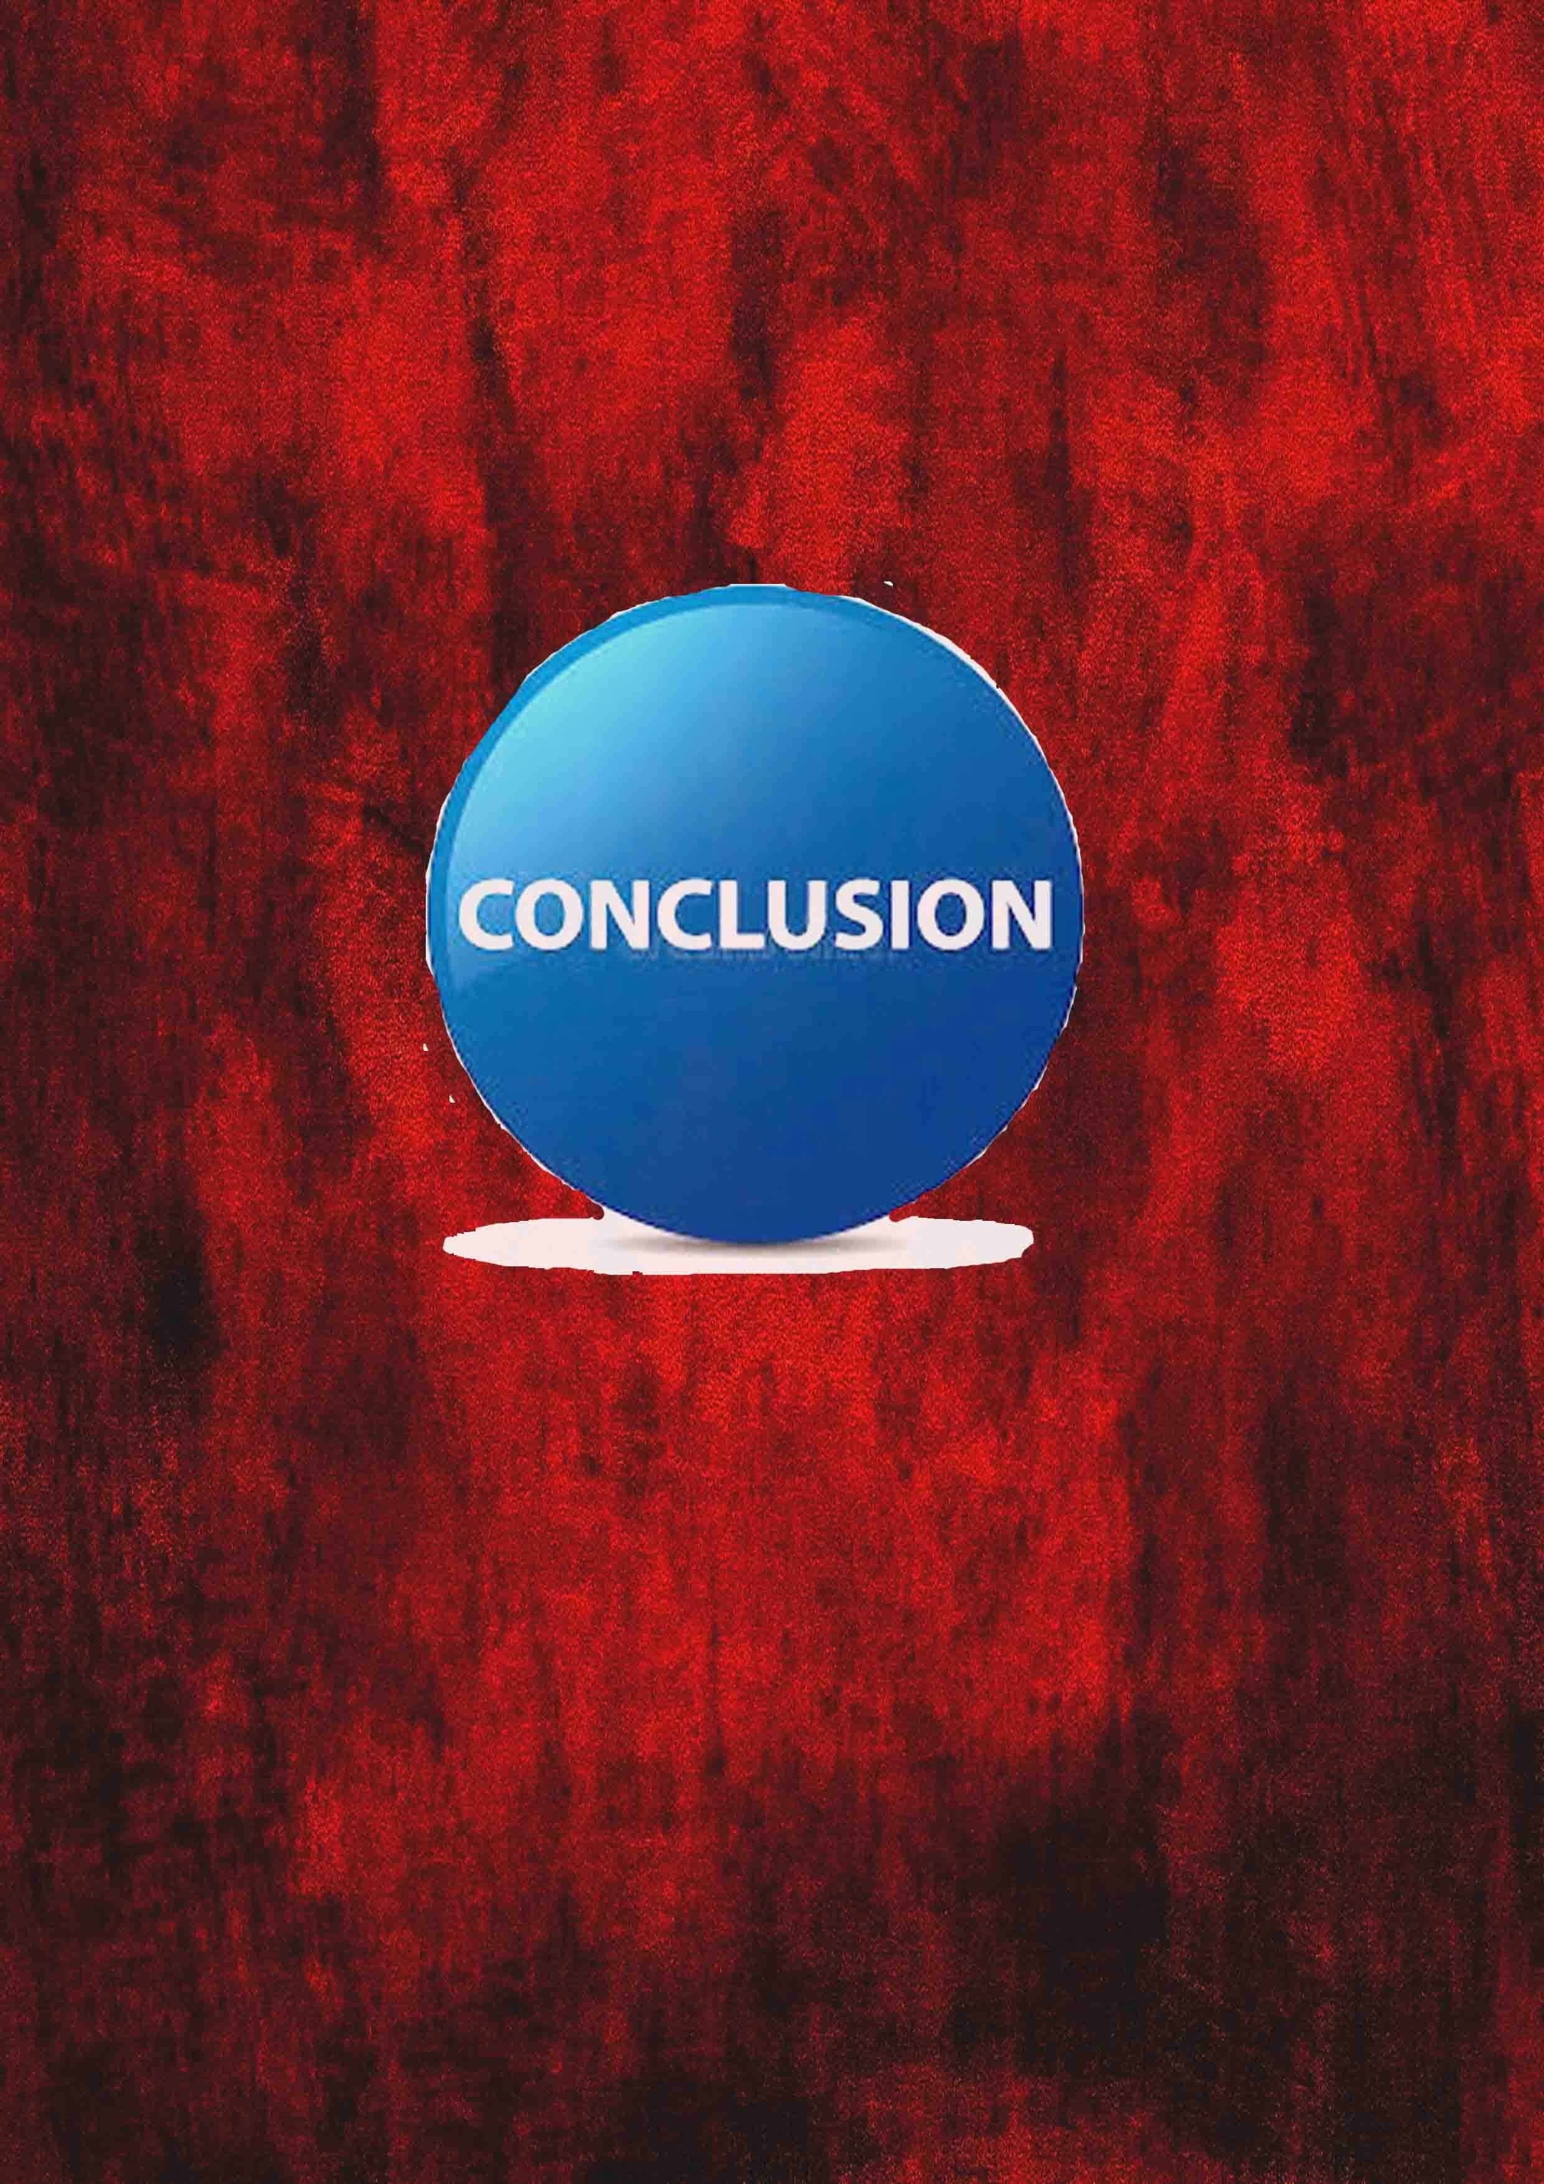

CONCLUSION
Human beings today tie with each other in the name of religion, race, language, c caste, colour and political allegiance so much so that violence, savagery, arson, genocide. The value oriented individuals seem to be vocal about the urgency of unity and harmony. It is ‘values’ that equip man with the sense of goal or prupose. They regulate our desires and actions. Man as a physiological organishm is propelled by instinctive drives and desires. The quality of living on the part of an individual and the collective body depends on the nature of ‘values’ they cherish. ‘values’ not only determine the course of man’s journey but it serves as the basis of intergration in the collective life. The individuals. Constituting the corporate body, might be different from each other in respect of caste, colour, creed, race and nationality. The values we imbibe make them oblivious of the superficial differences. In social sphere, the values, institutions, sentiments, philosophies are expedient for human happiness and progress. ‘Values’ is the prime necessity in corporate living. The nature of values to be imbibed, depends on the nature and composition of the society. Society stands in need of holistic values. It serves as a protasis of universal brotherhood (Vasudeva kutumbakam). ‘Human society is one and indivisible’. Humanity on the basis of community, race, colour, religion, political affilation, economic standard is not different but onea s a whole.
Value system provides norms of our behavious. The concept of purusartha is an intergrated approach to the value system. Man is a social animal. Purusartha deals with the ideals of life or goal of life. Values play an important role in life. The doctrine of purusarthas offers a complete value system both from the point of view of content and structure. It is based on a complete view of man and society. In Indian tradition human life is treated as the totality of multiple dimensions. Man has physical, psychic, moral and spiritual needs. These needs are represented through fourfold purusarthas. The purusarthas constitute one of the most important themes in Indian philosophy and culture. Artha and kama stand respectively for the acquisition of wealth and the enjoyment of the present life and dharma represents religious merit.
Human life without purpose would be meaningless. One needs to have an end or purpose in life towards our actions to be directed. Prusarthas are going to add meaning to our life. Purusartha means aim or goal of human life. The purpose of life is to follow the law (dharma of god) and achieve salvation (moksa) or freedom from false self leading balanced life both material comforts and human passions. They provide structure and meaning to human life and give us a reason to life with a sense of duty, moral obligation and responsibility. The word ‘purusartha’ is a Sanskrit compound that directly translates to human purpose. Hindus realize the four simple goals to leading a fulfilled life viz artha recognizes the need for material things in order to live a suitable life. Kama understand the need to enjoy worldly happiness. Dharma incorporates finding the truth by leading a disciplined life. Moksa is the final objective of life and is to gain freedom from worldly sufferings and inevitably the continuous cycle of birth and death. This can be ach9ieved by leading virtuous, righteous and disciplined life.
The four fold values do constitute an integral schemata reconstruct or envision model of an ideal life. Artha and kama are to be harmonized the principles of dharma. Artha, kama and dharma are not incompatible for the attainment of moksa. Artha and kama become morally viable, assume the value character. Purusarthas only prove to be expedient for the attainment of moksa. The purusarthas serve as pointers in the life of a human being. The doctrine of purusraths or the goal of life helps us to find a peace of mind which is the birth right of every human being. Atha, kama, dharma and moska have been construed as fourfold cardinal values. It corresponds to the human nature. Artha as economic interests or wealth, kama as the satisfaction of sexual, emotional and artistic life and moksa as the liberation of spirit. Purusartha means aims or goals of human life. Artha in the old Sanskrit lexicons is said to mean meaning, money. Artha means the attainment of riches and worldly prosperity, advantage, profit and wealth. Artha is a powerful urge in human nature. Today everyone is running after money. People need money to meet their basic necessities, for higher education, for luxuries of life, for name and fame. The misuse of artha leads to social ills. Artha or wealth is not everything. Without wealth other values would be in peril. Artha fulfills satisfaction of the human needs and wants of materialaids. Artha denotes all types of material goods needed for individuals normal living and subsistence. Artha means objectives. Artha stands for economic value which stands for the meaning of life. Artha in the Indian traditional value perspective wants to emphasis the view that every person has a right to earn his livelihood, to accumulate wealth and property. Wealth and pleasure, as the values in Indian philosophy wants to emphasize a good life to be lived for an individual being. The artha or wealth acquired the place in the Indian value system of social aspect attached to it. Artha helps for attainment of kama. Artha acquiring wealth and resources means to attain individual purpose and live a sutfilled life. Artha (acquisition of wealth) is a prerequisite for the basic necessities of life, which constitute one of the focal concerns of the individual. Artha the satisfies human desire. Artha is the fundamental factor in all human pursuits. Artha or wealth becomes evil or an agency to perpetuate evil which is put to wrong uses.
Kama is the gratification of desires, the pleasure of attaining individuals purpose and fulfilling individuals dharma. Kama is fulfilling one’s desires. Desires are in various forms to be wealthy, powerful, sexual needs, recognition service. Kama defines the goal of life. Kama is a necessary element in human life and one of the aims of human life. Valmiki says kama is an irresistible force. Kama is the subordinate to dharma and artha. Kama subjects to dharma and artha. Dharma and artha follow kama (lust). Lust disturbs the social and moral order of the society. Every individuals seek pleasure and luxuries of life. Nobody wants to stay at the bottom level. People feel that money is the important factor in the attainment of the pleasures of life, fulfilling individuals desires. Kama is said to be a categorical representation or hypostatization of man’s appetitive life of pursuits. Kama means pleasure or agreeable feeling resulting out of the satisfaction of desire.
Dharma is the divine constitution which defines our roles and responsibilities, social and moral order, purpose and goals. Every human being needs to obey the law of nature. Dharma is the stability of the society, the maintains the social order. Dharma is higher than artha and kama. One can attain moksa provided artha and kama have been cultivated by dharma. Dharma gives values to kama and artha. Dharma is the only intrinsic values. It is attained by self restraint. Dharma and artha produce prosperity and happiness in heaven and on earth. Vice (adharma) produce evil and harm. Dharma is the supreme way and the supreme goal of man. Good conduct of virtuous person is the eriterion of righteousness. There is no dharma that doesn’t contain truth. The mind directs the senses to their functions. The mind is righteously disposed, the senses do not go astray. Evil springs from desires. Pursuit of kama alone never leads to dhara. True happiness comes from dharma.
Dharma is always held higher than artha and kama. Dharma helps man to fulfill the obligations of artha and kama directed to the ultimate end of moksa. The classical Indian society is divided th individual life into four stages as asrams and the society into four castes known as varnas. This division and its assumptions have naturally fromed the background for the theory of purusarthas. Dharma means ethics, morality, virtue, spirituality, truth and good conduct.
In moksa one secures immortality, free from the cycle of birth and death. The term ‘moksa’ in its generic sense stands for the highest value. It is construed as the summum bonum of human life and marks the fruition of all ambitions and aspirations. Moksa in its wider connotation signifies the highest value, which imparts the meaning and significance to other. Moksa can be construed as supplying the final justification for all human actions. Final justification is intimately connected with the final end of life. Moksa (liberated state) has been construed as the state of highest good, summum boum of human lie. Moksa, is the atonement with the supreme godhood, is the highest state of religious realization. Moksa means the attainment of a state free from all pain. Moksa is the highest state being and becoming. Moksa is accorded a place of paramount importance among the purusarthas. Man being basically divine, exhibits the natural craving for infinite happiness. The carving for infinite gets fulfilled only in the highest state of moksa. It is the constitutional necessity of man. It is the end of man’s journey and marks the fulfillment of one’s aspiration. Man’s struggle for obtaining happiness pursuing artha and kama are imperfect expressions of man’s craving for infinite happiness. He remains eer dissatisfied for he does not tread upon the right way leading to ultimate happiness.
Moksa is the highest state of perfection and happiness. Moksa, regarded as the paramapurushartha, freedom from the chain of birth and death, suffering, freedom (action), freedom from attachment to the objects of desires, release from bondage. Moksa stand for the spiritual principle and is said to be a state of bliss. It is the consummation of the process of our moral development and the ultimate goal of human life.

BIBILOGRAPHY
1. Anandamurti., Discourses On Krisna And Gita, Ananda Marga Press,
Calcutta, 1994
2. Banerjee, N.V.. Glims of Indian Wisdompse, Munshiram Manoharlal,
New Delhi, 1772
3. Bary, De., Sources of Indian Tradition, Motilal Bansaridass,
Delhi 1972
4. Basham, A.L., The Wonder that was India,k Sidgwick and Jackson,
London, 1969
5. Bruton, R and Arbuthnot, F.F., The Kama Sutra, George Allen and
Unwin Ltd., London, 1963.
6. Bulher, G., The Laws of Manu, Motilal Banarsidass, 1964,
7. Chennakesavan, S., Critical Study of Hinduism, Asia Publishing
House, Bombay, 1974.
8. Creel, Austin B., Dharma in Hindu Ethios, Firma K.L.M. Pvt. Ltd.,
Calcutta, 1977
9. Colebrooke, H.T., Essays on the Religion and Philoshophy of the
Hindus, Indological Book House, Delhi, 1972.
10. Devaraja, N.K. The mind and Spirit of India, Motilal Banarasidass,
Delhi, 1967
11 Domadaran, K., Inidan Thought: A Critical Survey., Asia Publishing
House, Bombay, 1967.
12. Gopalan, S., Hindu Social Philosophy, Wiley Eastern Ltd., Delhi
1979.
13. Goyndka, Jayadayal., Gems of Truth, Gita Press, Kolkata, 2013.
14. Goswami, Narmada., The Journey of Self Discovery. The Bhaktivedanta Book Trust, Mumbai, 2006.
15. Haughton, G.C(Ed)., Manu Dharma Sastra, Cosmo Publication
New Delhi, 1982
16. Hiriyanna, M., Outlines of Indian Philosophy, Allen and Unwin,
London, 1970.
17. hiriyanna, M., Inidian Concept of Values, Kavyalay Publishers,
Mysore, 1975.
18. Hopkins, E.W., Ethics of India, Yale Unibersity Press,
New Haven, 1924.
19. hopkins, E.W. (Ed), The Ordinances of Manu, Oriental Books
Reprint Corporation, New Delhi, 1971,
20.lyer, K.B., Hindu Ideals, Bharatiya Vidya Bhavan, Bombey, 1969.
21.Joshi, G.N., Atman and Moksa, Gujrat University, Ahmedabad, 1965.
22. Khan, Benjamin, The Concept of Dharma in Valmiki Ramayana,
Munshiram Manoharlala Oriental Book Sellers and Publishers,
Delhi, 1965.
23.Kanal, S.p.. Dialogues on Indian Culture, Panchal Press Publication
Delhi, 1955
24. Kane, P.V., History of Dharmasastra, Bhandarkar Oriental Research
Institute, Poona, 1974.
25. Kangle, R.P.M The Kautilya Arthasastra, Motilala Banarsidass, Delhi,
1969
26. Krishnamurti, J., The First and Last Freedom, Krishnamurti Foundatin
India, Chennai, 2001.
27. Mackenzie, J., Hindu Ethics, Oxford University Press, London, 1922.
28. Mackenzie, J.. Outlines of Social Philosophy, George Allen and
Unwin, London, 1956.
29. Maira, S.K., The Ethics of the Hindus, Asian Publication Series, New Delhi, 1978
30. Moghe S.G., Studies in the Dharma-Sastra, Ajanta Book Publicatios,
Delhi, 1991.
31. Mohapatra, P.K., Society, Culture and Value, Utkal University Press,
Bhubaneswar, 2008,
32. Mohanty, A.K., Philosophy of Value, Elite Publication, Bhubaneswar,
1995
33. Mohanty, A.K. Dharma, Elite Publication, Bhubaneswar, 1998.
34. Mohanty A.K., Concets and Issues in Indian Philosophy, Elite
Publication, Bhubaneswar, 2008.,
35. Michael, Aloysius., Radhakrishan on Hinndu Moral Life and Action,
Concept Publishing Co., Delhi, 1979.
36. Mittal, K.K., Materialism in Indian Thought, Munsiram Manoharlala
Pvt. Lid., New Delhi, 1974
37. Moore, G.E., Principia Ethica, Cambridge Universty Press, 1971.
38. Motwani, K., Manu Dharma Sastra, Ganesh and Co., Madras, 1958.
39. Mukherjee, R., The Social Structure of Values, S.Chand, New Delhi,
1965.
40. Narain, Harsh., Facets of Indian Religio-Philosophic Identity, Bharatia
Vidya Prakashan, Delhi, 1983.
41.Padhi, N.C., and Panigrahi S.C., Ethics: Indian and Western, AnanyaPublications, Bhubaneswar, 2010,
42. Panigrahi, S.C., Issues in Inndian Ethics, Ananya Publication,
Bhubaneswar, 2006.
43. Parker, H., The Philosophy of Values, Greenwood Press, New York,
1968.
44. Perry, David L. The Concept of Pleasure, Mouton and Co., aris, 1967.
45. Pralehu, P.H., Hindu Social Organization, Popular Prakashan, Bombay,1963.
46. Poddar, Hanumanprasad., Path to Divinity, Gita Press, Kolkata, 2013.
47. Radhakrishnan, S., Religion and Society, George Allen and Unwin
Ltd., London, 1959.
48. Radhakrishnan, S., The Hindu View of Life, Unnwin Books, London,
1971.
49. Rao, P. Nagaraja., Essays in Indian Philosophy and Religion, Lalvani
Publishing House, Bombay, 1971..
50. Roubiczek, Paul., Ethical Values in the age of Science, Cambridge
University Press, 1969.
51. Sharma, D.S., Renascent Hinduism, Bharatiya Vidya Bhavan, Bombay,
1966.
52. Sharma, I.C.. Ethical Philosophies of Inndia, Johnson Publishing
House, Nebraska, 1965.
53. Sharma, Chandradhar.. A Critical Survey of Indian Philosphy, Motilal
Banarsidass, New Delhi, 1987.
54 Siddhantalankar, S., Heritage of Vedic Culture, D.B. Taraporvevala
Sons and Co. Pvt. Ltd., Bombay, 1969.
55 Spratt, P., Hindu Culture and Personality Manaktalar, Bombay, 1967.
56. Suda, J.P., Religion in India, Sterling Publishers Pvt. Ltd., New Delhi.
1978.
57. Upadhaya, K.N. The Bhaagabad Gita and Early Buddism, Motilal
Banarasidass, Delhi, 1971.
58. Walker, K, and Fletcherm P., Sex and Society, Pelican Books, 1962
59. Zimmer, H., Philosophies of India. The World Publishing Co. New Work, 1964.

